The Story of Rev’d James John Christie
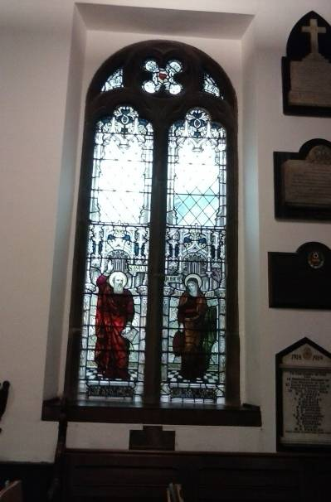You may remember that I used a photo of this window in the North Aisle as the cover picture for the Service Sheets for the Fourth Sunday of Easter. The dedication to the people to whom the window is the dedicated is written as a combination of initials and Roman Numerals for the dates of their deaths. The little plaque under the window gives us the actual names of the people to whom the window is dedicated:

A.M.D.C.
IN LOVING MEMORY OF THE REV.
JAMES JOHN CHRISTIE FOR 21
YEARS VICAR OF PONTEFRACT
AND MARIA AUSTIN WARMAN HIS
WIFE THIS WINDOW AND TABLET
ARE ERECTED BY THEIR SONS
They rest from their labours and
their works do follow them
So who was Rev’d James John Christie?
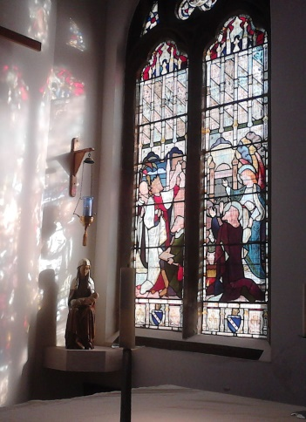James and his wife Maria were both born on the island of Jersey, one of the Channel Islands. Before becoming Vicar of Pontefract he is recorded as being in 1861 Second Master at the East Retford Grammar School and in 1871 as Clergyman without the care of souls and schoolmaster at Rotherham Grammar School.
James became Vicar of Pontefract 1878 replacing the Scot, Rev’d Thomas Bisset. Thomas is remembered for undertaking the last major reordering of St Giles’ before the reordering in 2012/13. It is Thomas’ window in the South Aisle that casts the pretty effect on a sunny day on the wall of The Lady Chapel.
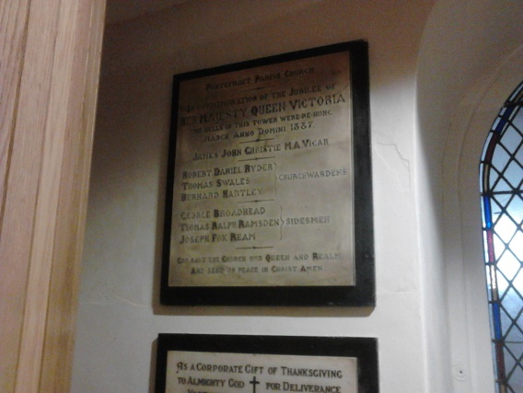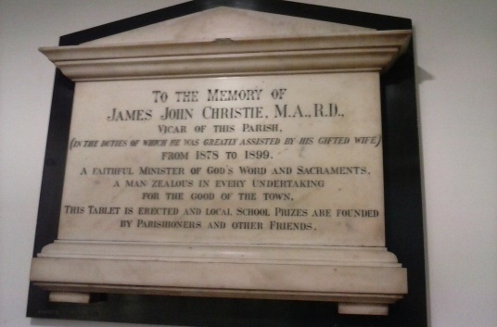James has another memorial in South Aisle behind the sound desk. It suggests that James was a popular vicar. However, James made himself very unpopular when he tried to reintroduce the system of tithes! A tithe is giving a tenth of your income to the church. In Medieval times tithes were collected in villages and divided between the parish priest, upkeep of the church, the poor and the bishop. When James attempted to reintroduce this, an effigy of him was burnt in the Market Place!
In 1887 Queen Victoria celebrated her Golden Jubilee. St Giles’ decided to mark this by rehanging the bells. A memorial to remember this event is at the back of the café.
James’ wife Maria died 1894. James continued as vicar until retiring in 1899. He died on Christmas Eve 1902. Although James made a mistake over trying to reintroduce tithes judging by the memorials and window he was clearly a popular vicar who worked hard to bring good things to Pontefract.
Jonathan Harris (research by Bruce Dalgleish)
Information on the tithes system was found on Google

